1. Write a python program for the following: – Input the string “Python” as a list of characters from console, delete at least 2 characters, reversethe resultant string and print it. Sample input:

Output:

2. Write a program that accepts a sentence and replace each occurrence of ‘python’ with ‘pythons’.

Output:

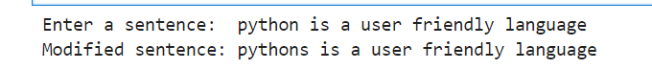

3. Use the if statement conditions to write a program to print the letter grade based on an input class score. Use the grading scheme we are using in this class.

Output:

